Longevity and Fecundity Protocol
Each alpha-amanitin concentration is treated separately. On the first day you see hatches, count the flies and measure their thorax lengths. For the following three days you will collect the flies, measure their thorax lengths, and place the flies into molasses vials. The ratio of males to females should be 1:1. If there are too many females, add white-eyed males from the w¹¹¹⁸ stock to obtain a 1:1 ratio. Do NOT record these white-eyed males on the tape or on the sheets. We will NOT count them, because we are only interested in the experimental strain. If there are too many males, collect the extra males and place them in their own vial. On the day the flies hatch, the DAY COUNT is ZERO. Below is an example of what the tape labels should look like (examples in red):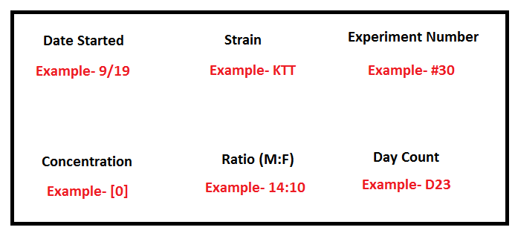

At about the same time on each day, switch the flies from one vial to a new vial with a little yeast paste at the bottom (either by knocking them out on a CO₂ pad or by bumping). Then write a new tape label, making sure to increase the day count and adjust the ratio on the label if any flies died. This will continue until all the flies have died.
Count the eggs in the molasses vials. This includes the eggs that have hatched already. Do NOT count the larvae. Eggs could be in the yeast, so make sure you look for them as well. Store the vials with the eggs at 4ºC if necessary, where they will not decay for several weeks.

